Child’s Name ________________________

Weekly Reading Minutes
Use the log below to record your weekly reading to self.
You must read the weekly reading story for two nights. The other two nights are your choice!
Please indicate in the middle columns the title of what you read as well as how long you read.
You should be reading for 30 minutes each night.
These logs are due on the last day of each week to record our classroom reading minutes.
Have fun and read, read, read!

Night of the Week | Reading Selection | Minutes | Parent Signature
Monday
Tuesday
Wednesday
Thursday |  | 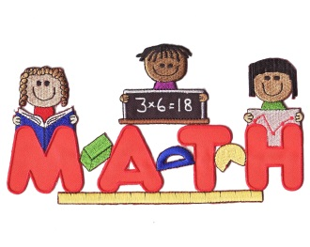

Weekly Math Minutes

Choose an activity to complete each night to practice your basic multiplication facts.
You should be practicing at least 5 minutes each night.
Night of the Week | Math Activity | Minutes | Parent Signature
Monday
Tuesday
Wednesday
Thursday
Choose one of the following activities to practice your math facts. You can choose a different one each night or find one that you like to play each day. If you come up with another activity, please share it with class!
Don’t forget: Practice makes perfect!

Online Games:
Funbrain.com- multiplication games

Freerice.com

Math Playground

Cool math games

math-play.com

multiplication.com/games

multiplication-games.org

fun4thebrain.com/mult.html

kidsmathgamesonline.com/multiplication.html

Math Activities:

Practice flashcards

Multiplication War

Multiplication Dice game

iPad, iPhone or iPod Apps:
Sushi Monster

Math vs Zombies
Kindle Fire or Android:
Let’s Do Math

Kid Math Game

Fun Math Tricks

Math Bingo

Math Training for Kids

Marble Math

Math Ninja

Mathmateer Free

Mathsquared

Madagascar Math Ops

All Apps listed are FREE!!!

